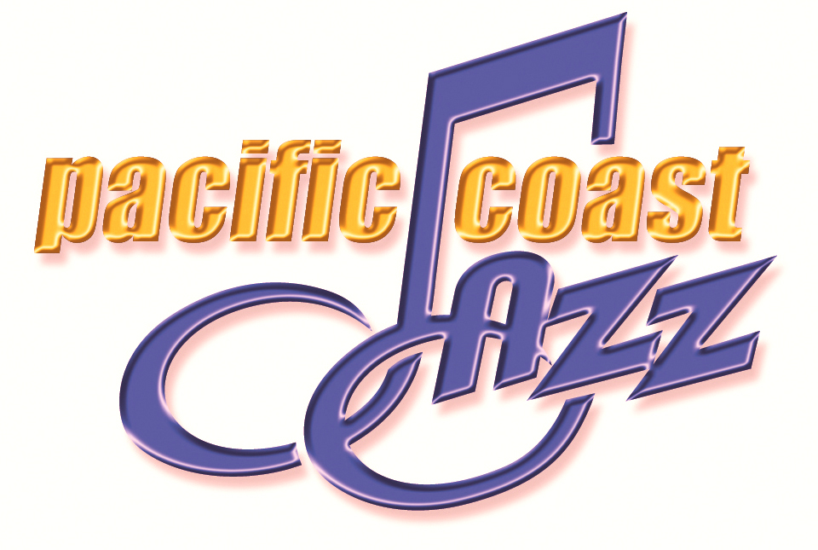
PRESS RELEASE

FOR IMMEDIATE RELEASE

media contact:

November 7, 2005 MEDIA ARTS, 760-877-0619

SAN DIEGO-based RECORD Label, PAcific Coast JazZ, Announces Signing of Bay Area Jazz vocalist, Sherri Roberts
SAN DIEGO, CA – San Diego-based independent record label, Pacific Coast Jazz (PCJ), is announcing the signing of San Francisco-based jazz vocalist, Sherri Roberts. Roberts’ own independent label, Blue House Recordings, will now be an associate label under the Pacific Coast Jazz umbrella.
Effective November 4, 2005, the agreement anticipates the release of Roberts’ third recording, The Sky Could Send You, slated for a street date of February 7, 2006. “The quality of Sherri’s work is outstanding,” says Donna Nichols, founder and president of Pacific Coast Jazz. “Her recordings are exceptionally well produced and very musical. They fit in perfectly with the caliber of product we like to put out.” Nichols’ label also will handle artist management services for Roberts and will give Blue House Recordings access to national media buying.
The third recording effort from the jazz vocalist, The Sky Could Send You is produced and arranged by bassist Harvie S (formerly Harvie Swartz), and features guest appearances by legendary saxophonist, Phil Woods and trumpet virtuoso, Lew Soloff. The CD also is the third collaboration between Roberts and Harvie S, following their critically acclaimed recordings on the Brownstone label, Twilight World (1996) and Dreamsville (1998), which charted for seven weeks on the prestigious Gavin Report. “My first two releases were more jazz blended with repertoire from the American Songbook,” says Roberts. “The new record fuses more Latin and world music with jazz elements. We believe that the audience for jazz is now coming from a broader perspective, and this album is designed to appeal to a more diverse crowd.” Drawing from a broad palette of instrumental and rhythmic colors, The Sky Could Send You features re-crafted jazz and Brazilian standards and original compositions by contemporary artists. The jazz and world grooves provide a rich foundation for Roberts’ liquid vocals and intimate lyric delivery.
Having delighted Bay Area fans for well over a decade, Roberts remains committed to introducing her audience to unusual standards. “I have always been very passionate about lyrics that tell a story. There are some beautiful standards that aren’t heard that often and I try to bring them into the spotlight.” A true scholar of American Popular Music, Roberts freely sites such diverse influences as Ella Fitzgerald, Carol Sloane, Chet Baker and Shirley Horn.
Pacific Coast Jazz, founded in 2003, is a boutique jazz label that also offers artist management services. Their catalogue also includes the recordings of jazz flutist, Bradley Leighton. Donna Nichols, the label’s founder and president, is formerly a successful communications executive in the biotech industry. “The label has allowed me to follow my passion for music and draw upon all of my experience in the corporate world,” says Nichols. Artists like Roberts find the unique combination of skills and passion to be a big plus. “I like the fact that Donna comes from a corporate background and brings all of that marketing expertise to the table but she also really loves music,” says Roberts. “As an artist, I need someone like that who can focus on the business aspect of getting a project to market and let me do what I do best.” Pacific Coast Jazz is currently pursuing the acquisition of new artists in the straight-ahead jazz and contemporary jazz genres. Says Nichols, “Our team has the talent and the contacts to handle the promotional demands for both of these markets successfully.”
All artists on the Pacific Coast Jazz label have access to Pacific Coast Jazz’s distribution channels, including Big Daddy Music in the United States and The Woods in the UK. For more information on Pacific Coast Jazz, please visit: www.pacificcoastjazz.com. For interviews with Pacific Coast Jazz or Sherri Roberts, please contact: MEDIA ARTS, 760-877-0619.
For more information on Sherri Roberts’ music, please visit: www.sherri-roberts.com.

